Lesson Plan: |  | Discovering your Entrepreneurial Competences using the ENTRECOMP Flower
Authors |  | Clod Priscilla Baumgartner, Isabell Grundschober
Class Information
Educator |  | Time/Location |  | No. of Students |  | Student Needs (SEN, Differentiation, etc.)
1 person |  | 1h 15Min |  | 11-20 |  | Suitable for learners with diverse backgrounds.
Lesson Focus
Reflecting on entrepreneurial competences using the ENTRECOMP framework and developing a personalized learning and development plan through peer coaching.
Intended Learning Outcomes: By the end of the lesson, students will be able to:
After successful completion of this activity learners will be able to:
- Understand the ENTRECOMP competences and how they manifest in practice.
- Self-evaluate their entrepreneurial competences.
- Find evidence of their entrepreneurial competences.
- Engage in peer-coaching to enhance their professional vision.
Develop a plan to improve their entrepreneurial competences.
Prior Knowledge (Any related topics or concepts students should be familiar with.)
Basic understanding of entrepreneurship and personal work experiences is helpful but not required. Learners should ideally have reflected on their personal strengths and development goals.
Success Criteria: Students will demonstrate success by:
- Completing a self-assessment using the ENTRECOMP Flower.
- Participating in peer-coaching rounds following the "Wise Group" format.
- Formulating at least one next step in their entrepreneurial competence development plan
Lesson Outline & Timing
Activity | Duration |  | Description
Introduction | 10 mins |  | Overview of the ENTRECOMP framework and its components, distribution of an empty ENTRECOMP flower sheet.
Self-Evaluation | 15 mins |  | Learners fill in the ENTRECOMP flower and self-evaluate their competences, reflect on which competences they can contribute to their business and which need improvement.
Reflection | 15 mins |  | Documenting competences and past examples, identifying areas for improvement and how to address them, formulating questions for peer-coaching.
Discussion and Peer-Coaching | 35 mins |  | Learners discuss their self-evaluation results with peers in groups of 3, the peer-coaching will be conducted according to the “wise groups” approach. Each person once takes the role of a “client”. The others act as “consultants”. Talking about strengths and weaknesses, risks, and mitigation strategies, plan next steps in their entrepreneurship competence learning journey.
Resources Needed
ENTRECOMP Flower template (print or digital) |  |  |  |  | Writing materials or digital devices
Assessment Method |  |  |  |  | Homework / Follow-up Task (Optional)
Self-assessment, peer feedback |  |  |  |  | Write a brief reflection on the planned development step
Optional: reflection paper or short presentation |  |  |  |  | Take the first step in implementing the plan and document the results.
□ Have you considered accessibility (e.g., plain language, colour contrast, captions)?
□ Does this lesson use inclusive examples and language?
□ Have you respected copyright and licensing requirements for all media, texts and external resources used?
Worksheet
Discovering your Entrepreneurial Competences
using the ENTRECOMP Flower
A learning activity contributed by Clod Priscilla Baumgartner (Founder of the Agency for Innovation and Entrepreneurship) and documented in cooperation with Isabell Grundschober (University for Continuing Education Krems) for the PROMISE Project
Welcome to the activity designed to help you develop professional noticing skills in entrepreneurship. This activity will guide you through a series of steps to observe, notice, evaluate and reflect on your entrepreneurial competences using the ENTRECOMP framework.
Step 1: Introduction to the ENTRECOMP Framework (10 minutes)
Listen to your teacher’s explanations about the ENTRECOMP framework or watch an explainer video about Entrecomp and the different competence areas. The teacher explains the activity and it goals. Alternatively, you could also watch the following video introduction to the activity by Clod Baumgartner. Step 1 could be also done as preparation for the activity beforehand, the links can be shared in an online learning/teaching space.
Step 2: Self-Evaluation (15 minutes)
- Fill in the Flower: Complete the ENTRECOMP flower and rate how well you think you demonstrate each competence area. For help you can use “EntreComp: A Practical Guide”. Rate your competence from 1-10, 1= very weak, 10= very strong. If it is very weak, you draw a point in the flower petal close to the centre. The stronger your competence is, the more outside is the point. Connect the dots with lines to get a visualisation of your entrepreneurial competence.
- Reflection: Reflect on which competences you can contribute to your business and identify areas for improvement.
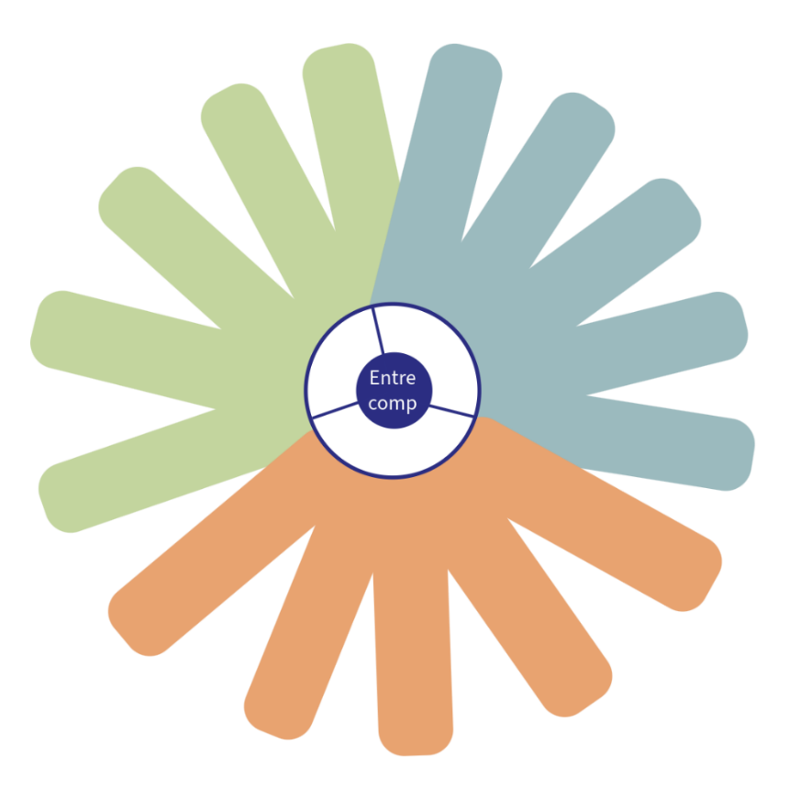
Step 3: Reflection (15 minutes)
Documenting: Use the provided table to document your competences, past examples, strengths, areas for improvement, action plans, and open questions.
Competence Area | Self-Evaluation (Rate your competence from 1-10, 1=very weak to 10=very strong) | Past Examples | Strengths | Improvement Areas | Action Plan for Improvement | Open Questions
Spotting opportunities
Creativity
Vision
Valuing ideas
Ethical and sustainable thinking
Self-awareness and self-efficacy
Motivation and perseverance
Mobilizing resources
Financial and economic literacy
Mobilizing others
Taking the initiative
Planning and management
Coping with uncertainty and risk
Working with others
Learning through experience

Step 4: Discussion and Peer-Coaching (35 minutes)
Share and Discuss: Discuss your self-evaluation results with a group of 3 people. There is 10 minutes of talking and discussing time for each person. The peer-coaching will be conducted according to the “wise groups” approach. Each person once takes the role of a “client”. The others act as “consultants”.
- Each person requesting a consult (the client) gets fifteen minutes broken down as follows:
- The client presents the challenge and request for help based on the identified strengths and weaknesses in the self-evaluation and reflection phase. What is unclear? What could be the risks? Next steps for improvement? Etc. 2 min.
- The consultants ask the client clarifying questions. 2 min.
- The client turns his or her back to the consultants and gets ready to take notes.
- The consultants ask questions and offer advice, and recommendations, working as a team, while the client has his or her back turned. 5 min.
- The client provides feedback to the consultants: what was useful and what he or she takes away. 1 min.
Benefits of the Activity
- Practical Understanding: This activity helps you understand how ENTRECOMP competences manifest in practice and how to identify them.
- Professional Vision: Develop a professional vision of entrepreneurial competences based on your own and shared experiences. This helps you noticing entrepreneurial competence in practice.
- Memory Retrieval: Learn to retrieve and document observations from memory, linking them to specific competences.
- Reflection Guidance: Guided questions support you in analyzing retrieved information and categorizing experiences into competence areas.
- Business Implications: Draw implications for business success from your analyzed observations.
- Visualization: Visualize the results of your reflection process using the blank ENTRECOMP flower.
Challenges
- Self-Reflection: Being honest and critical in self-reflection can be challenging but is crucial for growth.
- Feedback Acceptance: Accepting and implementing constructive feedback can be difficult but is essential for development.

